Java Design Patterns

TODO Head Frist java design patterns book and author have curse
Pattern Hatching : https://www.amazon.com/Pattern-Hatching-Design-Patterns-Applied/dp/0201432935
https://www.industriallogic.com/xp/refactoring/
https://www.amazon.com/dp/0321127420 (https://martinfowler.com/eaaCatalog/)
https://www.amazon.com/dp/0321200683
https://www.amazon.com/dp/0321127420
https://www.amazon.com/dp/0471958697
http://wiki.c2.com/?DesignPatternsBook

http://wiki.c2.com/?HistoryOfPatterns

https://learning.oreilly.com/library/view/pattern-oriented-software/9780471486480/

https://learning.oreilly.com/library/view/design-it/9781680502923/

Intro:
have a good name of patterns
Create a diagram of pattern system software

Types

Creational
Abstract instatiation process.
E.g. Singleton, Builer

Behavioral
Encapsulate algorithms and behavior, complex control flow
E.g. Strategy, Command, Visitor

Structural
Compose groups of objects into larger structures
E.g. Composite, Decorator, Proxy

Builder

Intent
Separate the construction of a complex object from its representation so that the same construction process can create different representations. (representation = implementation)

Two types
remove problem of telescoping constructor → look in Effective java book → use if object can have optional parameters

second → polymorphic construction

Polymorphic construction
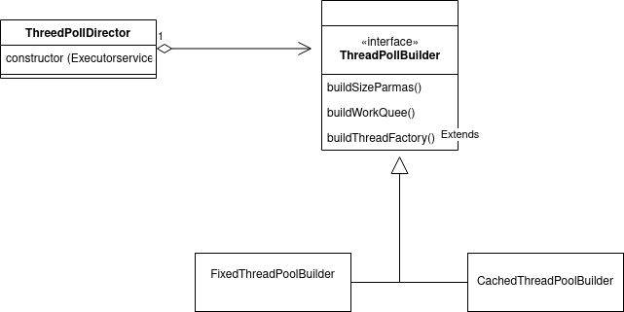
Each Java Thread is connected to native (machine) thread

GOF builder
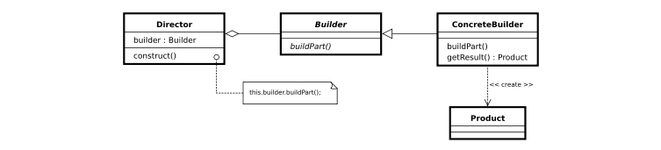
https://en.wikipedia.org/wiki/Builder_pattern

the Director class doesn't create and assemble the ProductA1 and ProductB1 objects directly. Instead, the Director refers to the Builder interface for building (creating and assembling) the parts of a complex object, which makes the Director independent of which concrete classes are instantiated (which representation is created). The Builder1 class implements the Builder interface by creating and assembling the ProductA1 and ProductB1 objects.
See: https://softwareengineering.stackexchange.com/questions/345688/what-are-the-advantages-of-builder-pattern-of-gof

example: https://www.geeksforgeeks.org/builder-design-pattern/

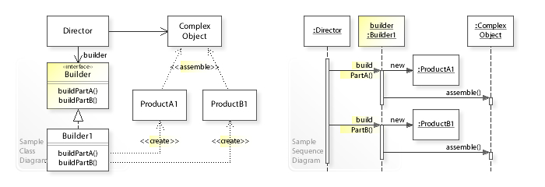
Also Polymorphic builder
https://stackoverflow.com/questions/9138027/builder-pattern-for-polymorphic-object-hierarchy-possible-with-java

https://newbedev.com/builder-pattern-for-polymorphic-object-hierarchy-possible-with-java

Use Builder
assemble complex objects from parts
where parts can vary without changing assembly algorithm

Validation do it constructor

Memento

Save and restore state of objects.
Another name is token.
It will externalize private fields of class (object)
Use memento to save snapsot of the object state so we can restore it
Also encapsulate state by not providing getters and setters
To store complete copies might be expensive (Prehaps only store incremental state)
Avoid memory leaks in place where you save memento (Caretaker) → WeakReference avoids memory leaks
You can make memento Seriazible.

Proxy

Proxy is a structural design pattern that lets you provide a substitute or placeholder for another object. A proxy controls access to the original object, allowing you to perform something either before or after the request gets through to the original object.
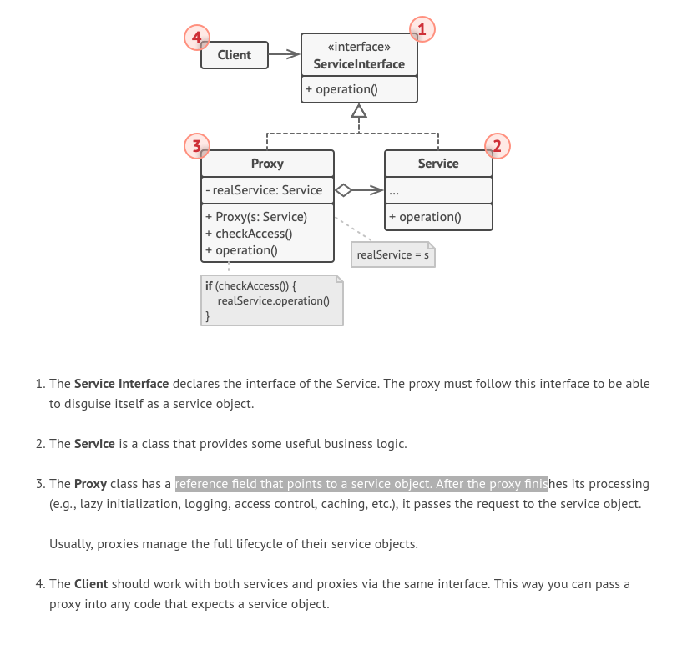
Client speak to out real object via a subject (proxy)
Sometimes structure (diagram) can be same (this is same or like Adapter pattern or Decorator) so the intent is also important.
In proxy we do not access the object direct, example a remote proxy hides that the real objects lives on another machine
Make sure that proxy and real object are different (equals and hashCode)
Also see VirtualProxy and DyamicProxy
see book Dynamic Proxies in Java

, a proxy is a wrapper or agent object that is being called by the client to access the real serving object behind the scenes. Use of the proxy can simply be forwarding to the real object, or can provide additional logic. In the proxy, extra functionality can be provided, for example caching when operations on the real object are resource intensive, or checking preconditions before operations on the real object are invoked. For the client, usage of a proxy object is similar to using the real object, because both implement the same interface.

More info here: https://stackoverflow.com/questions/11404327/proxy-memento-patterns
https://en.wikipedia.org/wiki/Proxy_pattern
http://best-practice-software-engineering.ifs.tuwien.ac.at/patterns/proxy.html

Strategy

Let the algorithm vary independently form clients that use it. You have family of algorithms (they implement the same interface)
Also known as the policy pattern

For instance, a class that performs validation on incoming data may use the strategy pattern to select a validation algorithm depending on the type of data, the source of the data, user choice, or other discriminating factors. These factors are not known until run-time and may require radically different validation to be performed. The validation algorithms (strategies), encapsulated separately from the validating object, may be used by other validating objects in different areas of the system (or even different systems) without code duplication.
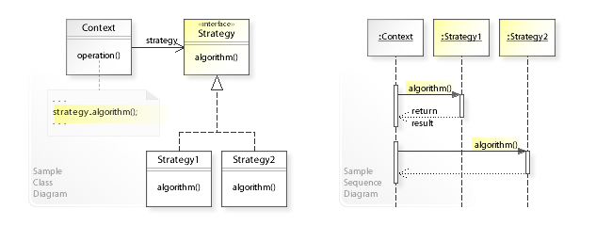

Composite

Client treat individual objects and “composition” object is same way. Compose object is hierarchie (tree) of same objects.

Client assemble objects into tree, then composite pattern simplifies clients by letting them treat individual object and part of the tree in same way.

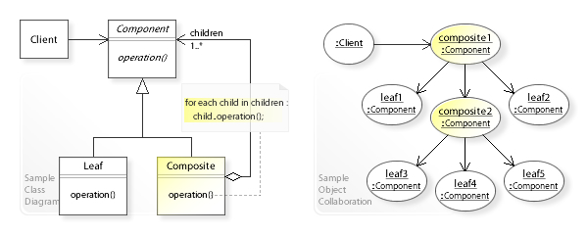

the Client class doesn't refer to the Leaf and Composite classes directly (separately). Instead, the Client refers to the common Component interface and can treat Leaf and Composite uniformly.
The Leaf class has no children and implements the Component interface directly.
The Composite class maintains a container of child Component objects (children) and forwards requests to these children (for each child in children: child.operation())

Can make your design too general. Like to proxy but is is one to many

